Lesson 18

Objective: Order numbers in different forms.

Suggested Lesson Structure

 Fluency Practice (12 minutes)

 Application Problem (8 minutes)

 Concept Development (30 minutes)

 Student Debrief (10 minutes)

**Total Time (60 minutes)**

Fluency Practice (12 minutes)

* Sprint: Sums–Crossing Ten **2.OA.2** (12 minutes)

Sprint: Sums–Crossing Ten (12 minutes)

Materials: (S) Sprint: Sums–Crossing Ten Sprint

This is the third day of our sums and differences intensive. Students heard you say yesterday’s sprint would be repeated today, and you’re keeping your word. Start the session by asking them to remember how many problems they were able to finish the day before.

T: That is your goal. Everyone’s goal is different because we are not competing so much with each other but with..?

S: Ourselves!

T: Your personal best. That is what matters. Share with your partner at least one strategy you use for practicing your sums and differences.

S: (Share.)

T: Here we go. Take your mark, get set, THINK!!

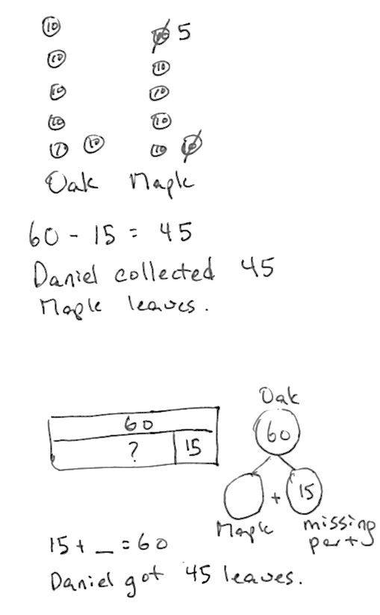Application Problem (8 minutes)

For an art project, Daniel collected 15 fewer maple leaves than oak leaves. He collected 60 oak leaves. How many maple leaves did he collect?

After guiding the students through the RDW process, let them analyze some work. Here are some suggested questions based on the drawings to the right.

* How does the number sentence relate to the drawing?
* How does the first drawing relate to the second drawing?
* What did the student who drew the number disks do to start the problem?
* Could the person who drew the number bonds also have started with making both the oak and maple leaves equal?

Can you see that equality in both pictures?

Concept Development (30 minutes)

Concrete (6 minutes)

|  |  |
| --- | --- |
|  | NOTES ON  MULTIPLE MEANS OF ENGAGEMENT: |
| As mentioned in Lesson 17, it is wise to provide visual support for struggling students. The teacher directives are coupled with the personal boards but are entirely oral. Write the directives as you say them so that students see the connections and build towards the chart.  **Partner A Partner B**  2 hundreds 12 ones 15 tens 4 ones  212 154  11 tens 9 ones 2 ones 1 hundreds  119 102  5 + 300 + 30 50 + 3 + 300  335 353 | |
| 5 tens + 3 tens 6 tens + 2 tens | |
| 8 tens 8 tens | |
|  | |

Materials: (T) Place value mat, number disks (9 hundreds, tens and ones) (S) Place value mat, number disks (9 hundreds, tens and ones), personal white boards and markers

T: Partner A, show 2 hundreds 12 ones on your place value mat. Partner B, show 15 tens 4 ones.

T: (As students work, project your own place value mat and use number disks to show 103.)

T: Compare numbers with your partner and me.

S: (Students compare.)

T: What’s the smallest number?

S: 103!

T: The greatest?

S: 212, or 2 hundreds 12 ones.

*T: Write the 3 numbers from smallest to greatest on your personal board. Use numeral form. At the signal, show your board.*

*S: (Students write 103, 154, 212.)*

*T: (Signal.) Good. Partner A, change to show 11 tens 9 ones. Partner B, change to show 2 ones 1 hundred.*

*T: (As students work, show 142 on your place value mat.)*

*S: (Students show.)*

*T: Now compare. Write the numbers from smallest to greatest on your board. (Pause. Signal.)*

*S: (Students compare and show 102, 119, 142.)*

T: Nice work. Partner A, change to show 5 + 300 + 30. Partner B, change to show 50 + 3 + 300.

T: (As students work, write ‘five hundred thirty three’ in word form instead of using number disks.)

S: (Students show.)

T: Compare our numbers. This time write them from greatest to smallest on your board. (Pause, signal.)

S: (Students compare and show 533, 353, 335.)

T: You paid careful attention to the order switching to go from greatest to smallest!

*T: Partner A, change to show 5 tens + 3 tens. Partner B, change to show 6 tens + 2 tens.*

*T: (As students work, write ‘eighty’ in word form.)*

*S: (Students show.)*

*T: Compare our numbers. Write them using the symbols <, >, or = to make a number sentence.*

*S: (Students compare and show 80 = 80 = 80.)*

Pictorial (12 minutes)

|  |  |
| --- | --- |
|  | NOTES ON  MULTIPLE MEANS OF REPRESENTATION: |
| Thinking of a number can be challenging for students below grade level. Provide some less intimidating ways to generate numbers:   * Digit cards * Spinners * Dice   Again, post the assignments with visual clues or examples, too.  Form Example | |
| A: Numeral Form 24  B: Unit Form 4 ones 2 tens  C: Word Form twenty four  D: Expanded Form 20 + 4 | |
|  | |

Materials: (T): Pocket chart, 1 set of <, >, = symbol cards   
(S) Personal white boards and markers

Assign students to groups by counting off as A, B, C, and D.

T: Write your letter on the blank side of your paper so you don’t forget it.

S: (Students quickly write their letters.)

T: Think of a number and draw it on your place value mat in the way that you choose.

T: Use hundreds, tens, and ones, or any combination of those you’d like. Take about 1 minute.

S: (Students think of numbers and draw them in a variety of ways.)

T: As, write your number in numeral form below your drawing. Bs, write numbers in unit form. Cs, write them in word form, and Ds, write them in expanded form.

Students are seated at the carpet.

T: (Collect papers. Place 3 student numbers side by side in the pocket chart with space between them.)

T: Work with your partner to order these 3 numbers on your personal white boards.

S: (Students order the numbers on their boards.)

T: Let’s read the numbers in order.

S: (Students read.)

T: (Trade drawings for 3 new ones and continue with 2 or 3 drawings at a time until each has been used at least once.)

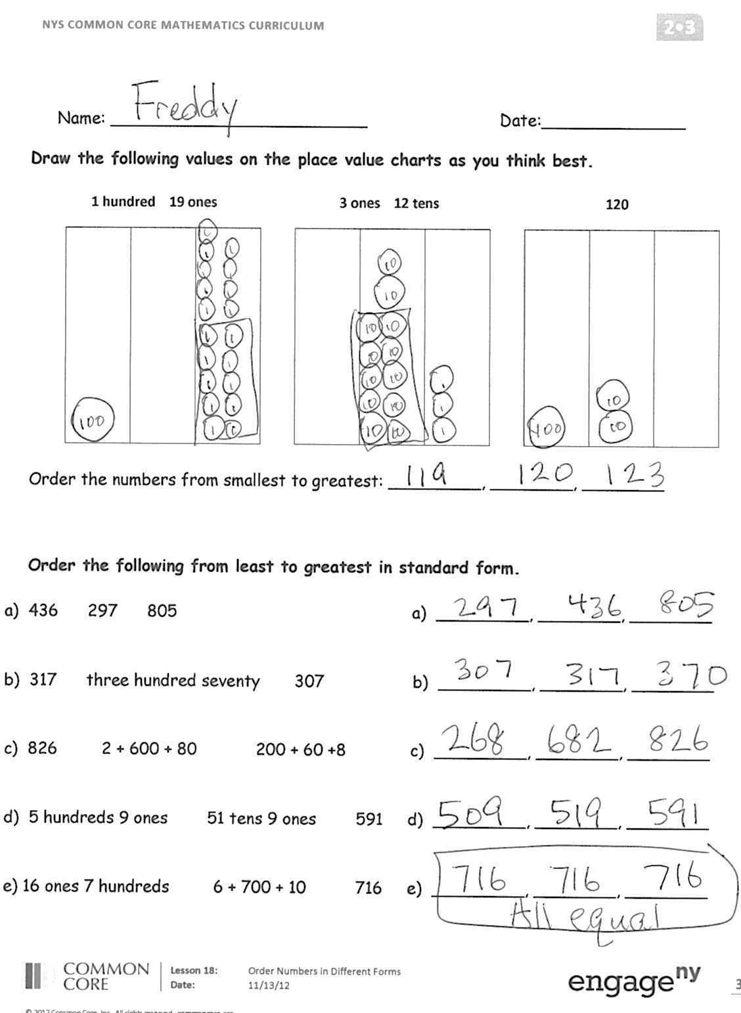Problem Set (12 minutes)

Students should do their personal best to complete the Problem Set within the allotted 12 minutes. For some classes, it may be appropriate to modify the assignment by specifying which problems they work on first. Some problems do not specify a method for solving. Students solve these problems using the RDW approach used for Application Problems.

Instruct students to draw the values on the place value chart as directed on the Problem Set, then order from least to greatest or greatest to least in numeral form. Write <, >, or =.

Student Debrief (10 minutes)

**Lesson Objective:** Order numbers in different forms.

The Student Debrief is intended to invite reflection and active processing of the total lesson experience.

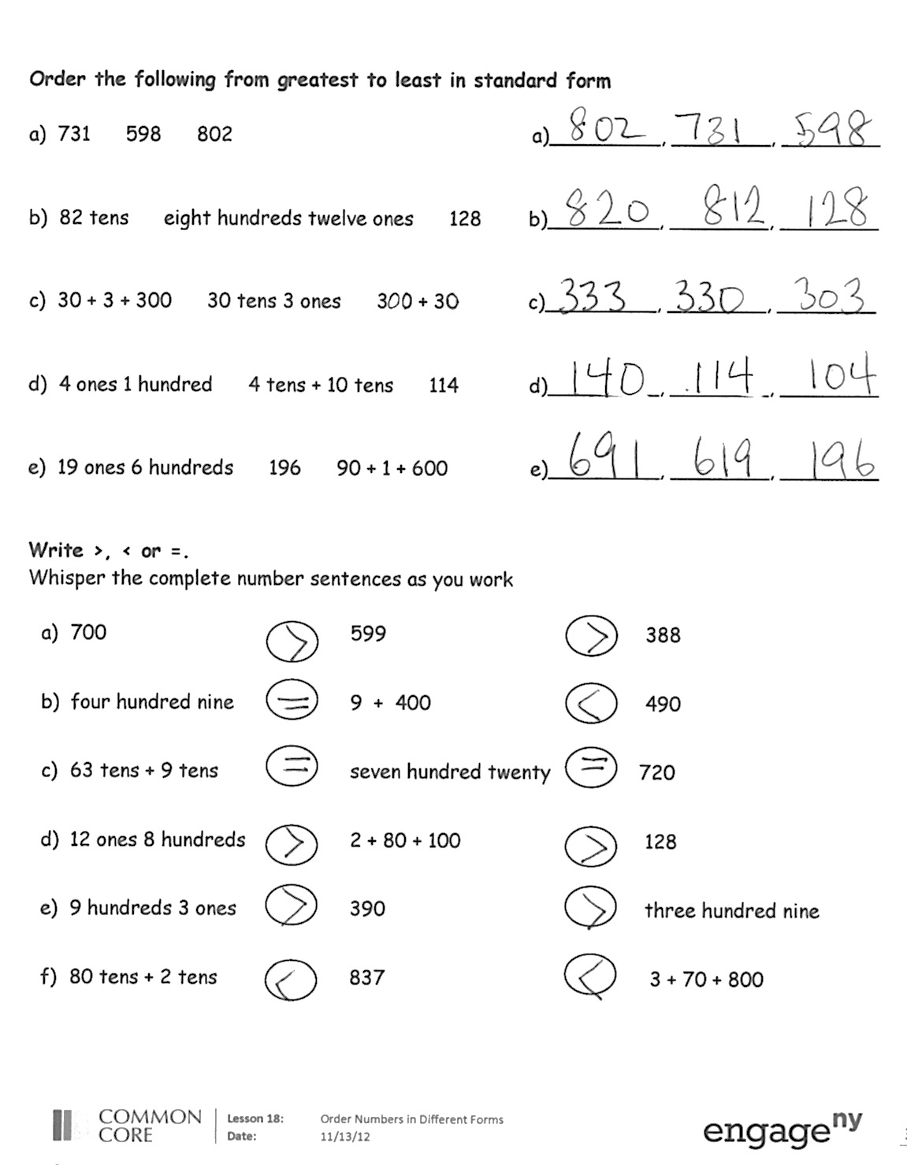Invite students to review their solutions for the Problem Set. They should check work by comparing answers with a partner before going over answers as a class. Look for misconceptions or misunderstandings that can be addressed in the Debrief. Guide students in a conversation to debrief the Problem Set and process the lesson.

T: Bring your Problem Sets to our Debrief.

T: Work with your partner to carefully check your answers.

S: (Students work for 2 minutes.)

T: Look at your drawings on your place value charts. Think about how your pictures are alike or different. Tell your partner.

S: I drew them just like the words say. They’re all different. 🡪 I used hundreds, tens, and ones in all of mine. 🡪 I drew them all differently, but then I wrote the numbers in numeral form. 🡪 I decided to only use tens and ones to show each number.

T: Look again. What about your drawings makes the numbers easy or difficult to compare?

S: It’s hard to compare them when they all are in different forms. 🡪 It’s also really hard when the units are mixed up.

T: How might you use what you know about comparing to help you order numbers well?

S: It helps to write all those different forms in the same way. Then it’s simple to put them in order.

T: True! Head back to your seats for your Exit Ticket.

Exit Ticket (3 minutes)

After the Student Debrief, instruct students to complete the Exit Ticket. A review of their work will help you assess the students’ understanding of the concepts that were presented in the lesson today and plan more effectively for future lessons. You may read the questions aloud to the students.



Name Date

1. Draw the following values on the place value charts as you think best.

**1 hundred 19 ones 3 ones 12 tens 120**

|  |  |  |
| --- | --- | --- |
|  |  |  |

|  |  |  |
| --- | --- | --- |
|  |  |  |

|  |  |  |
| --- | --- | --- |
|  |  |  |

Order the numbers from smallest to greatest: _________, ________, ________

1. Order the following from smallest to greatest in numeral form.

|  |
| --- |
| a. 436 297 805 a. _________, ________, ________ |
| b. 317 three hundred seventy 307 b. _________, ________, ________ |
| c. 826 2 + 600 + 80 200 + 60 +8 c. _________, ________, ________ |
| d. 5 hundreds 9 ones 51 tens 9 ones 591 d. _________, ________, ________ |
| e. 16 ones 7 hundreds 6 + 700 + 10 716 e. _________, ________, ________   1. Order the following from greatest to smallest in numeral form. |

|  |
| --- |
| a. 731 598 802 a. _________, ________, ________ |
| b. 82 tens eight hundreds twelve ones 128 b. _________, ________, ________ |
| c. 30 + 3 + 300 30 tens 3 ones 300 + 30 c. _________, ________, _______ |
| d. 4 ones 1 hundred 4 tens + 10 tens 114 d. _________, ________, ________ |
| e. 19 ones 6 hundreds 196 90 + 1 + 600 e. _________, ________, ________   1. Write ›, ‹ or =.   Whisper the complete number sentences as you work. |

1. 700 599 388
2. four hundred nine 9 + 400 490
3. 63 tens + 9 tens seven hundred twenty 720
4. 12 ones 8 hundreds 2 + 80 + 100 128
5. 9 hundreds 3 ones 390 three hundred nine
6. 80 tens + 2 tens 837 3 + 70 + 800

Name Date

1. Order the following from smallest to greatest in numeral form.

|  |
| --- |
| a. 426 152 801 a. _________, ________, ________ |
| b. six hundred twenty 206 60 tens 2 ones b. _________, ________, ________ |
| c. 300 + 70 + 4 3 + 700 + 40 473 c. _________, ________, ________ |
| 1. Order the following from greatest to smallest in numeral form.  |  | | --- | | 1. 4 hundreds 12 ones 421 10 + 1 + 400 a. _________, ________, ________ | | 1. 8 ones 5 hundreds 185 5 + 10 + 800 c. _________, ________, ________ | |

Name Date

1. Draw the following values on the place value charts as you think best.

241, 412, 124

|  |  |  |  |  |  |  |  |  |  |  |
| --- | --- | --- | --- | --- | --- | --- | --- | --- | --- | --- |
|  |  |  |  |  |  |  |  |  |  |  |

Order the numbers from smallest to greatest: _________, ________, ________

1. Order the following from smallest to greatest in numeral form.

|  |
| --- |
| a. 537 263 912 a. _________, ________, ________ |
| b. two hundred thirty 213 20 tens 3 ones b. _________, ________, ________ |
| c. 400 + 80 + 5 4 + 800 + 50 845 c. _________, ________, ________ |
|  |

1. Order the following from greatest to smallest in numeral form.

|  |
| --- |
| a. 11 ones 3 hundreds 311 10 + 1 + 300 a. _________, ________, ________  b. 7 ones 9 hundred 79 tens + 10 tens 970 b. _________, ________, ________ |
| c. 15 ones 4 hundreds 154 50 + 1 + 400 c. _________, ________, ________ |